**RIGA HOCKEY CUP**  
Injury Tracking and Concussion Protocol

Season 2025

**Introduction**  
The RIGA HOCKEY CUP Injury Tracking and Concussion Protocol is developed based on the International Ice Hockey Federation (IIHF) medical guidelines (Medical Regulations 2024/2025). The protocol governs the tracking of injuries during the tournament, as well as the procedures to follow when there are suspicions of a concussion during practice or a game.

**Injury Tracking**

RIGA HOCKEY CUP uses the injury definition provided by the International Ice Hockey Federation:

1. An injury is considered reportable if a player misses a practice or a game because of an injury sustained during a practice or a game
2. The player does not return to the play for the remainder of the game following an injury
3. All concussions
4. All dental injuries
5. Any laceration which requires medical attention
6. All fractures

Every injury must be recorded by the medical personel according to IIHF injury report (supplementary file no1), indicating:

1. Player's number;
2. Time of injury during the game;
3. Affected body area (right/left arm/leg, torso, head, neck).

**Concussion Protocol**  
The RIGA HOCKEY CUP Concussion Protocol is based on the International Ice Hockey Federation's document (International Ice Hockey Federation Concussion Protocol), utilizing the latest and most up-to-date data and research. The protocol's goal is to ensure player safety and health during games and training.

**Acute Concussion Assessment (supplementary file no2)**  
Concussion symptoms may appear immediately after a blow to the head or body, or they may develop over time (hours or even days after the injury). Therefore, players diagnosed with or suspected of having a concussion should stop the game or training and undergo an assessment of symptoms and signs over time.  
Any player (including goalkeepers) or referee who shows one or more concussion symptoms or signs after a direct or indirect contact should be removed from the playing environment as soon as possible. The team staff who observe the mentioned symptoms or signs must report their observations to the tournament's medical staff. The RIGA HOCKEY CUP medical supervisor has the right to request an evaluation in the locker room if visible concussion signs are observed on the field.

**Visible Signs of Concussion**

* Lying motionless on the ice – a player lies motionless on the ice or falls to the ice in an unprotected manner (i.e., without stretching out his hands or arms to lessen or minimize his fall).;
* Motor incoordination/balance problems – A player staggers, struggles to get up or skate properly, appears to lose his balance, trips or falls, or stumbles while getting up, trying to get up, or skating.;
* Disorientation (e.g., unsure of where he is on the ice or location of player bench);

**Concussion Symptoms (reported by the player)**  
• Headache;  
• Dizziness;  
• Balance or coordination difficulties;  
• Nausea;  
• Amnesia regarding the circumstances surrounding the injury;  
• Slowed thinking;  
• Increased sensitivity to light and sound;  
• Confusion, impaired ability to orient in time and place;  
• Visual disturbances;  
• Ringing in the ears (tinnitus).

Players or referees suspected of having a concussion should be assessed by the tournament’s medical personnel (doctor, athletic trainer, physiotherapist) in a neutral environment. If the team has its own medical staff, they will assess the player on-site and will be fully responsible for diagnosing the concussion. If the team’s medical staff is unavailable, the tournament’s chief doctor will take over this role.

**Return to Play**  
If the team’s medical staff determines after an assessment that the player or referee shows no signs of a concussion, they may return to the game.  
If a concussion is not found after an assessment, the player may return to the game.  
A player or referee with suspected or diagnosed concussion must be immediately removed from the game and cannot return to play the same day.  
Players or referees with visible signs unrelated to injury in another part of the body should not return to the game and will be evaluated the following day.

After a short rest period (24 to 48 hours after the injury), a player who has suffered a concussion should gradually increase their activity level, as long as these activities do not induce or worsen symptoms. The player follows a gradual return-to-play strategy, taking each step for no less than 24 hours. If physical activity worsens any symptoms, the athlete should return to the previous step.

| **Stage** | **Goal** | **Activity** | **Goal for each step** |
| --- | --- | --- | --- |
| 1. | Activity without symptoms | Daily activities without symptoms | Gradual return to work/school activities. |
| 2. | Light aerobic exercise | Increase heart rate. |  |
| 3. | Sport-specific exercise | Add movement. | Coordination and increased thinking. |
| 4. | Non-contact training | Restore confidence and assess functional skills under coach supervision. |  |
| 5. | Full contact training | Participate in regular training activities with medical clearance. |  |
| 6. | Return to play | Regular game. |  |

An athlete may return to play once the team's medical staff or the tournament's chief doctor confirms normal neurocognitive function and successful gradual return to play.  
The team's medical staff may consult with the tournament's chief doctor. If the tournament's chief doctor disagrees with the decision of the team’s medical staff, they will contact the tournament organizers, who have the authority to remove the player from the competition.

Supplementary file no1.

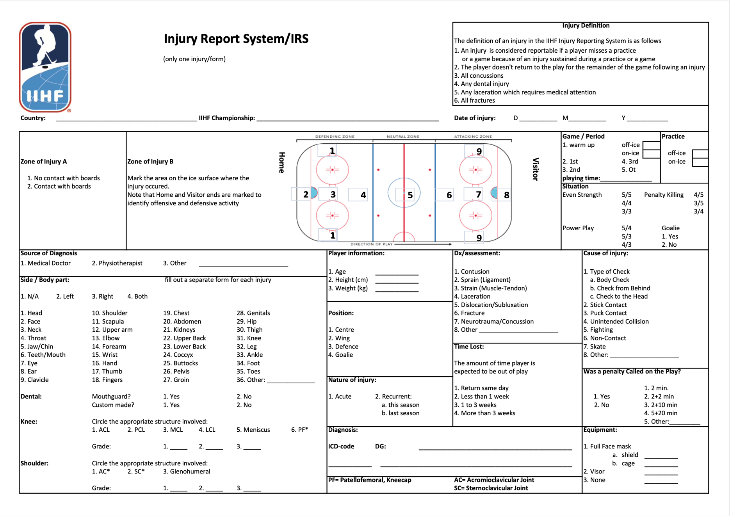

Supplementary file no2.

